**Bytewise Fellowship Deep Learning**

**Abdul Rehman**

1. Change into the project‘s root folder on the command line and use the “git init” command to start versioning this project:

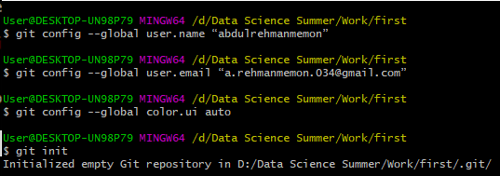

1. The files in that directory

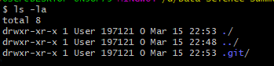

1. Ignoring Files

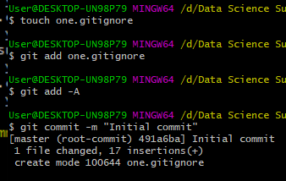

1. Commit by staging some changes with the “git add”.

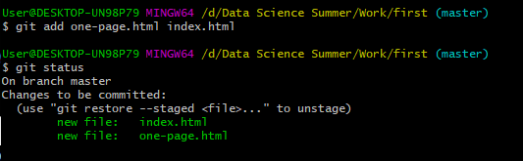

1. Adding commit message

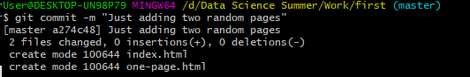

1. Display the project‘s commit history:

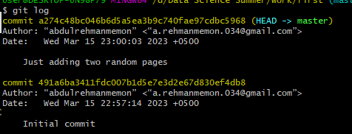

1. Check detailed changes

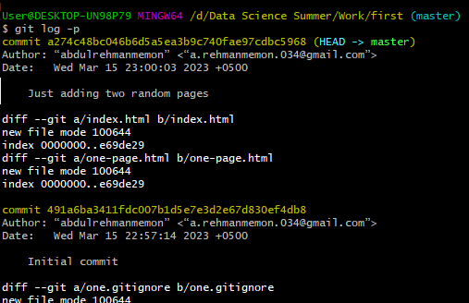

1. Create new branch



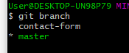

1. Saving work temporary

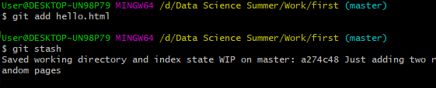

1. Switch to newly created branch (contact-form)



1. integrate the changes from our “contact-form” branch into “master”:



1. Full practice

Create directories, different files, branches, merge

